Node JS and NPM(Node Package Manager)

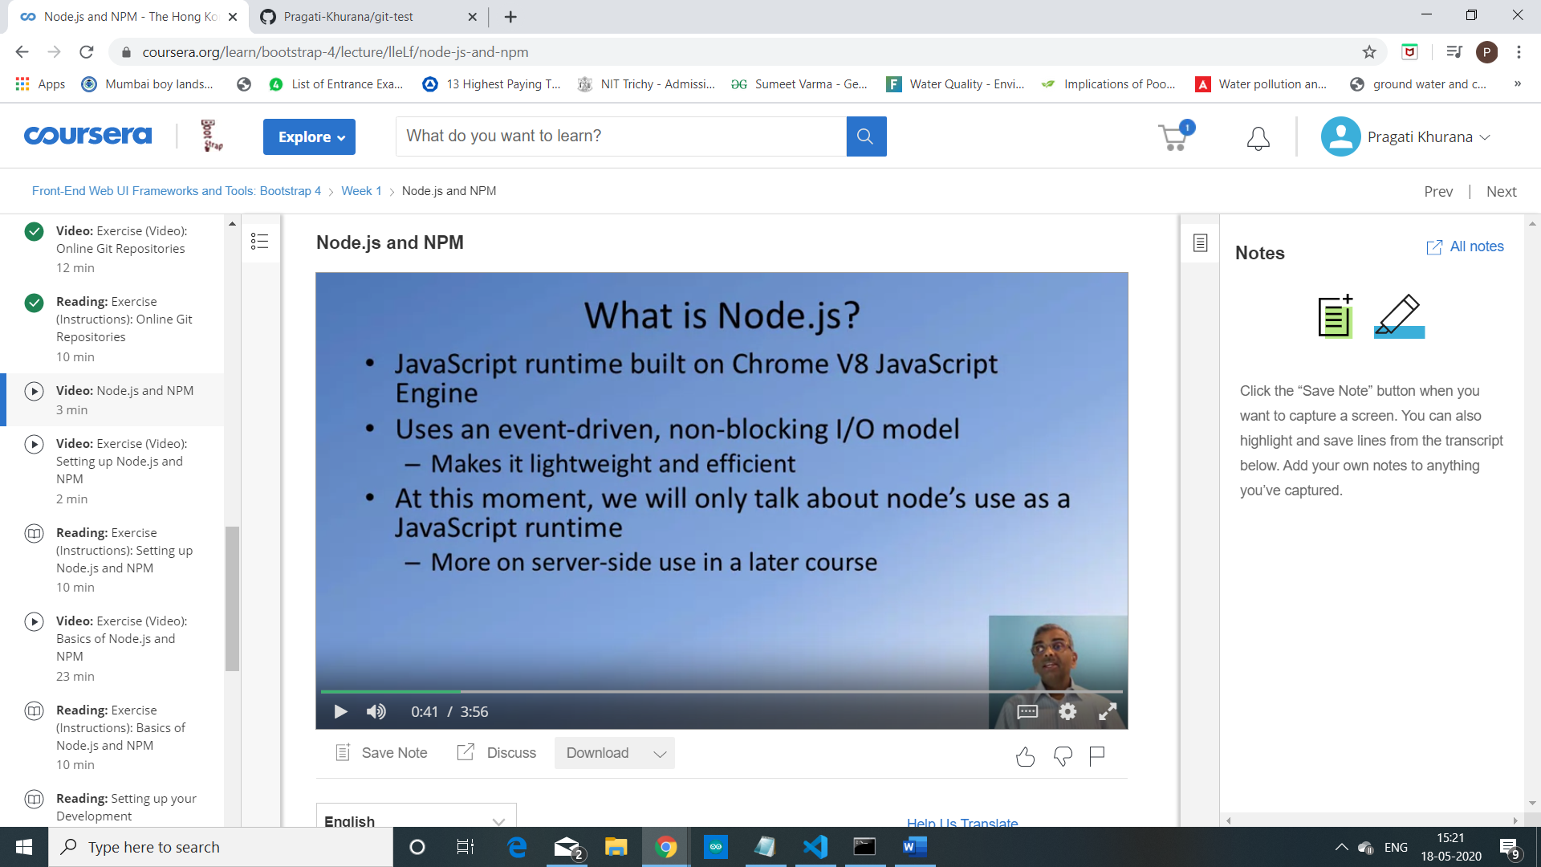

Node.js, as I mentioned earlier,

allows us to bring the power of JavaScript to the desktop.

Node js is based on the JavaScript runtime

engine that has been built for the Chrome browser.

So the Chrome V8 JavaScript Engine has been ported from the browser to run

on the desktop and support the execution of JavaScript programs on the desktop.

Node.js is built around an event-driven,

non-blocking I/O model which makes it very efficient to run JavaScript

programs on the desktop, asynchronous JavaScript on the desktop.

Now this is where Node finds its true polish.

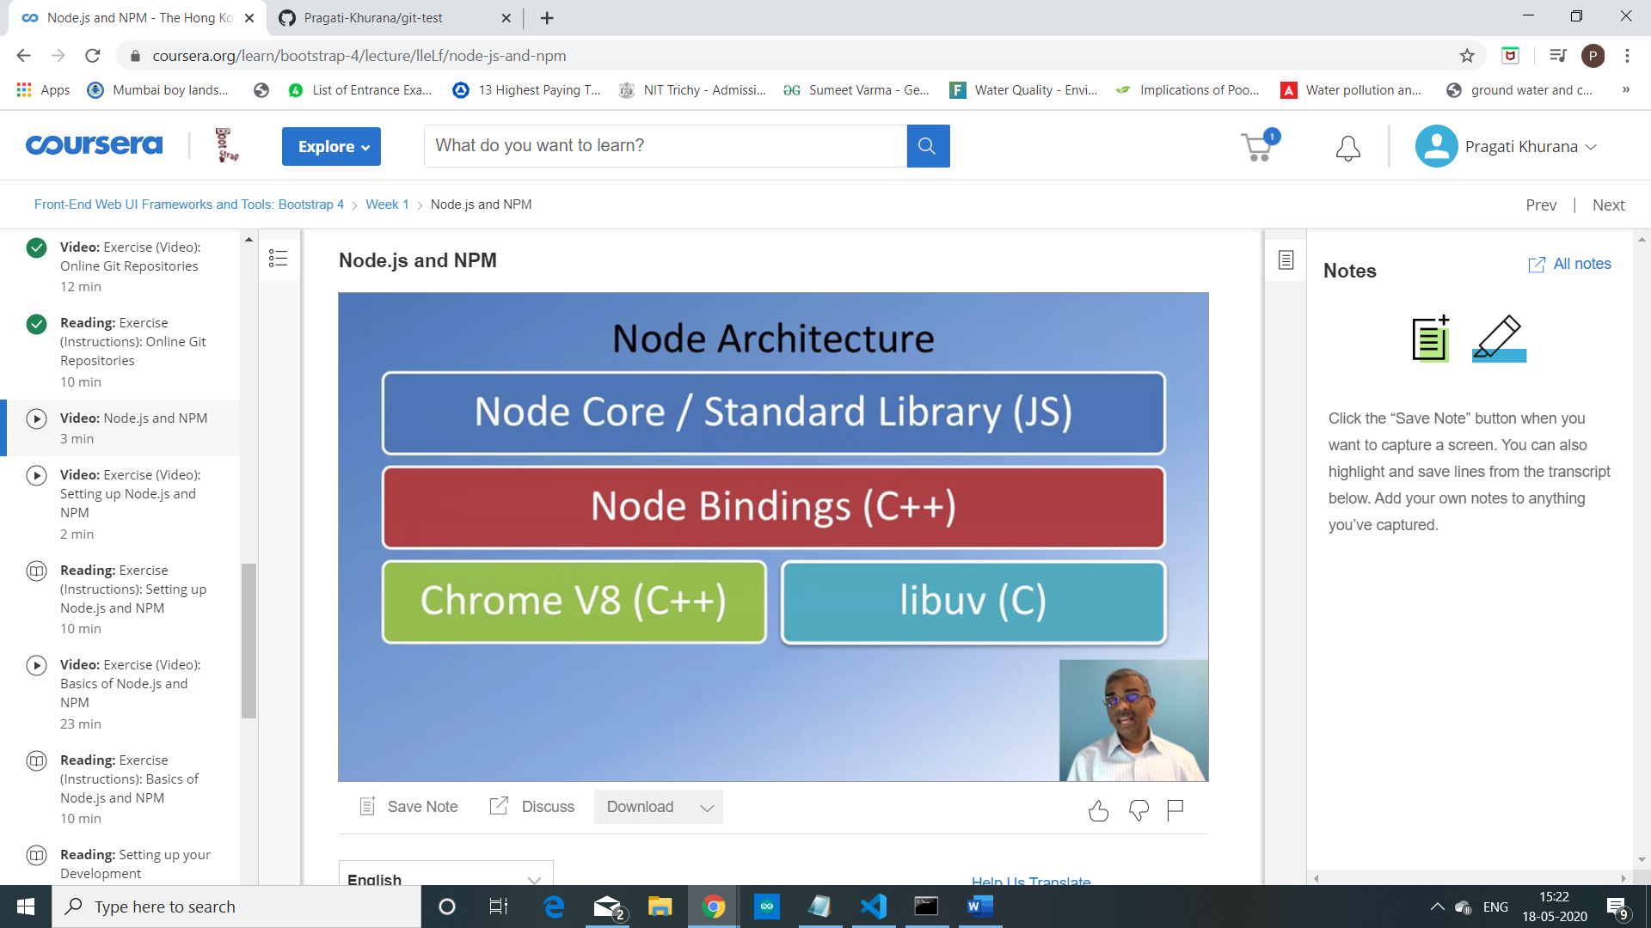

This is the typical architecture of Node.js.

So in this, the Chrome V8 engine is the bottom layer together with

libuv, forms the layer that interacts with

the underlying computer system to support the execution of JavaScript programs.

On top of it we have Node Bindings which is also implemented in C++.

At the top layer you have the Node.js and

Standard Library, which are all implemented in JavaScript and this is what

enables us to write JavaScript programs and run them on the desktop.

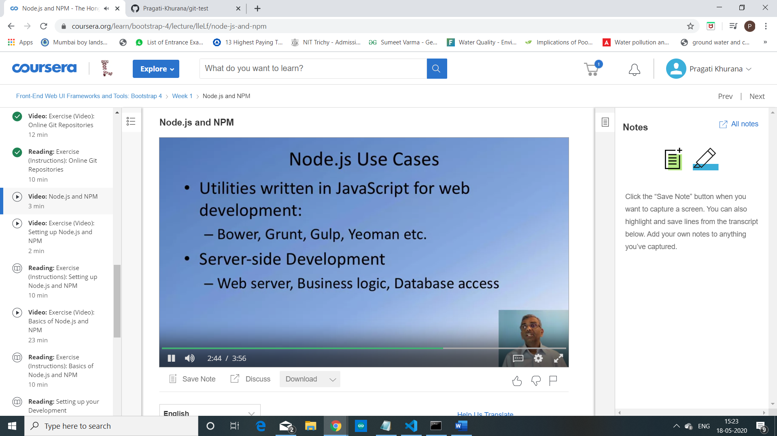

Naturally the ability to run JavaScript programs on the desktop

energize the web development community to explore using

JavaScript to develop a significant number of web development tools.

Tools such as Bower, Grunt, Gulp, Yeoman, and many others.

When you install Node on your computer NPM automatically gets installed.

The Node package manager is the manager for the Node ecosystem.

It manages all the Node modules and

packages that have been made publicly available by many different users.

A typical Node package consist of JavaScript files together with

a file called package.json which is the manifest file for this Node module.